**LAB NOTE**

**Subject: Electronic Design Principles**

**Topic: Astable Multivibrator**

**Student: Minh Quan Tran**

**May , 2024**

Table of Contents

1. Objectives 4

2. Theory and Design 5

2.1 Theory 5

2.2 Design and Calculation 5

3. Result 6

3.1 16 Hz 6

3.1.1 Calculation for equipment 6

3.1.2 Multisim Design 6

3.1.3 Breadboard Design 7

3.1.4 Result 8

3.2 33 Hz 9

3.2.1 Calculation for equipment 9

3.2.2 Multisim Design 9

3.2.3 Breadboard Design 10

3.2.4 Result 11

3.3 80 Hz 12

3.3.1 Calculation for equipment 12

3.3.2 Multisim Design 12

3.3.3 Breadboard Design 13

3.3.4 Result 14

3.4 5 Hz 15

3.4.1 Calculation for equipment 15

3.4.2 Multisim Design 15

3.4.3 Breadboard Design 16

3.4.4 Result 17

3.5 20 Hz (67% ON and 33% OFF) 18

3.5.1 Calculation for equipment 18

3.5.2 Multisim Design 18

3.5.3 Breadboard Design 20

3.5.4 Result 21

4. CONCLUSION 22

**TABLE OF FIGURES**

Figure 2‑1: Astable Multivibrator Circuit 5

Figure 3‑1: Circuit design with R = $47kΩ$ and C = 1 $μF$ 6

Figure 3‑2: Circuit's output for 16 Hz 7

Figure 3‑3: Breadboard's design for 16 Hz 7

Figure 3‑4: Breadboard's output for 16 Hz 8

Figure 3‑5: Circuit design with R = $22kΩ$ and C = 1 $μF$ 9

Figure 3‑6: Circuit's output for 33 Hz 10

Figure 3‑7: Breadboard's design for 33 Hz 10

Figure 3‑8: Breadboard's output for 33 Hz 11

Figure 3‑9: Circuit design with R2 = and C2 = 12

Figure 3‑10: Circuit's output for 80 Hz 13

Figure 3‑11: Breadboard's design for 80 Hz 13

Figure 3‑12: Breadboard's output for 80 Hz 14

Figure 3‑13: Circuit design with R2 = and C2 = 15

Figure 3‑14: Circuit's output for 5 Hz 16

Figure 3‑15: Breadboard's design for 5 Hz 16

Figure 3‑16: Breadboard's output for 5 Hz 17

Figure 3‑17: Circuit design with R2 = 47k, C2 = and R3 = 22k, C1 = 18

Figure 3‑18: Circuit's output of Chanel 1 for 20Hz (67% ON, 33% OFF time) 18

Figure 3‑19: Circuit's output of Chanel 2 for 20Hz (33% ON, 67% OFF) 19

Figure 3‑20: Breadboard's design for 20 Hz 20

Figure 3‑21: Breadboard's output for 20Hz (Channel 1) 20

Figure 3‑22: Breadboard's output for 20Hz (Channel 2) 21

**~~~~~~~~~~~~~~~~~~~~~~~~~~~~~~~~~~~~~~~~~~~~~~~~~~~~~~~~**

**TABLE’S OF TABLE**

Table 3‑1: Result for 16 Hz 8

Table 3‑2: Result for 33 Hz 11

Table 3‑3: Result for 80 Hz 14

Table 3‑4: Result for 5 Hz 17

Table 3‑5: Result for 20 Hz 21

# Objectives

To create a working Astable Multivibrator using 2 BJTs, LEDs and capacitors.

Step 1: Design and calculate the equipment in the circuit.

Step 2: Simulate the result in Multisim to test the theory.

Step 3: Build the circuit based on theory and Multisim design.

# Theory and Design

## Theory

Astable-Multivibrator basically is used to generate the square waves at a desired frequencywithout any external intervention.

## Design and Calculation

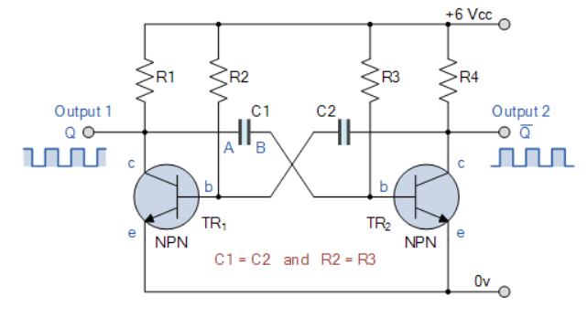

Figure 2‑1: Astable Multivibrator Circuit

For this design the following equipment are use:

* 4 Resistor
* 2 Capacitor
* 2 BJT Transistors
* Power Supply

Astable Multivibrator’s Periodic time (for Output 1):

|  |  |
| --- | --- |
| $$\left\{\begin{aligned}T =t_{1}+t_{2} \\ t_{1}=ln\left(2\right) ×R_{2}×C_{2} \\ t_{2}=ln\left(2\right) ×R_{3}×C_{1}\end{aligned}\right.$$ | (2.1) |

*Equation 2‑1: Astable Multivibrator's Periodic time formula*

For this assignment, 5 sample frequencies will be tested.

# Result

## 16 Hz

### Calculation for equipment

Because $R_{2}= R_{3}$ and $C_{1}= C_{2}$ so,

$$t_{1}= t_{2}= ln\left(2\right) ×R_{2}×C_{2}$$

To design an Astable Multivibrator with frequency of 16Hz, the periodic time will be:

So t1 and t2 will be.

From the result, choosing R2 = and C2 = 1 will give the closest time:

$$t_{1}= ln\left(2\right) ×R_{2}×C_{2}=32.5 \left(ms\right)$$

$$f= \frac{1}{T}= \frac{1}{2 × t_{1}}=15.38 (Hz)$$

### Multisim Design

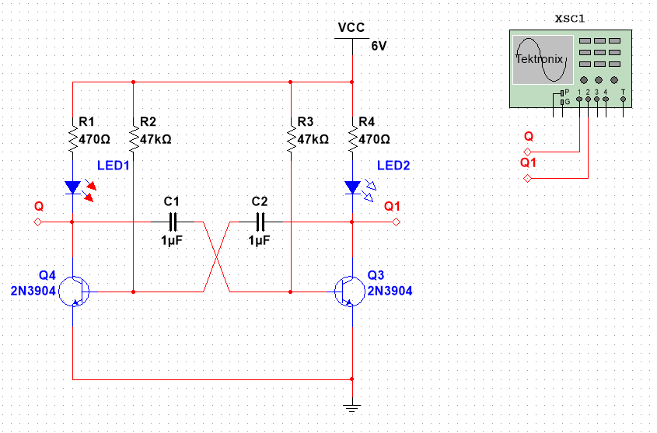

Figure 3‑1: Circuit design with R = $47kΩ$ and C = 1 $μF$

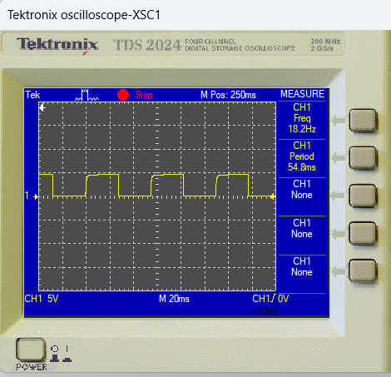

Figure 3‑2: Circuit's output for 16 Hz

### Breadboard Design

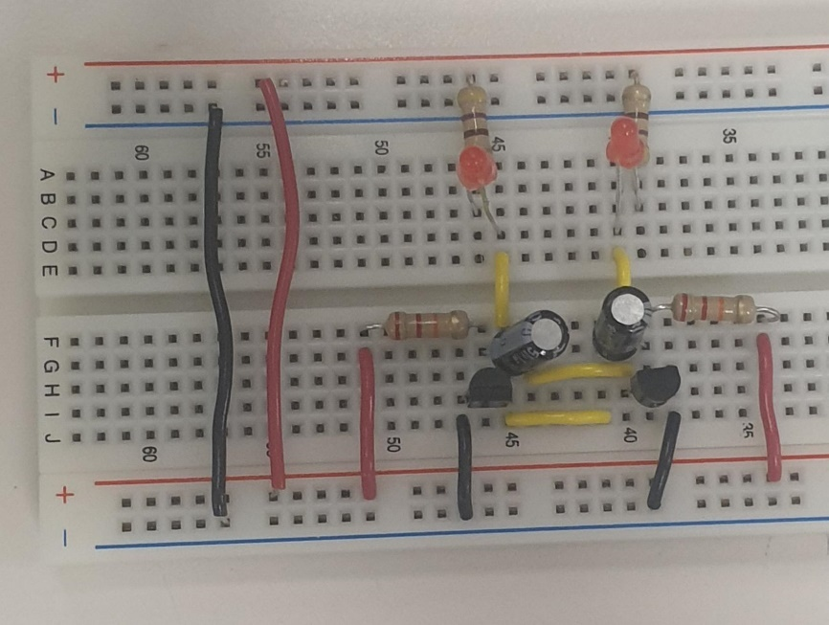

Figure 3‑3: Breadboard's design for 16 Hz

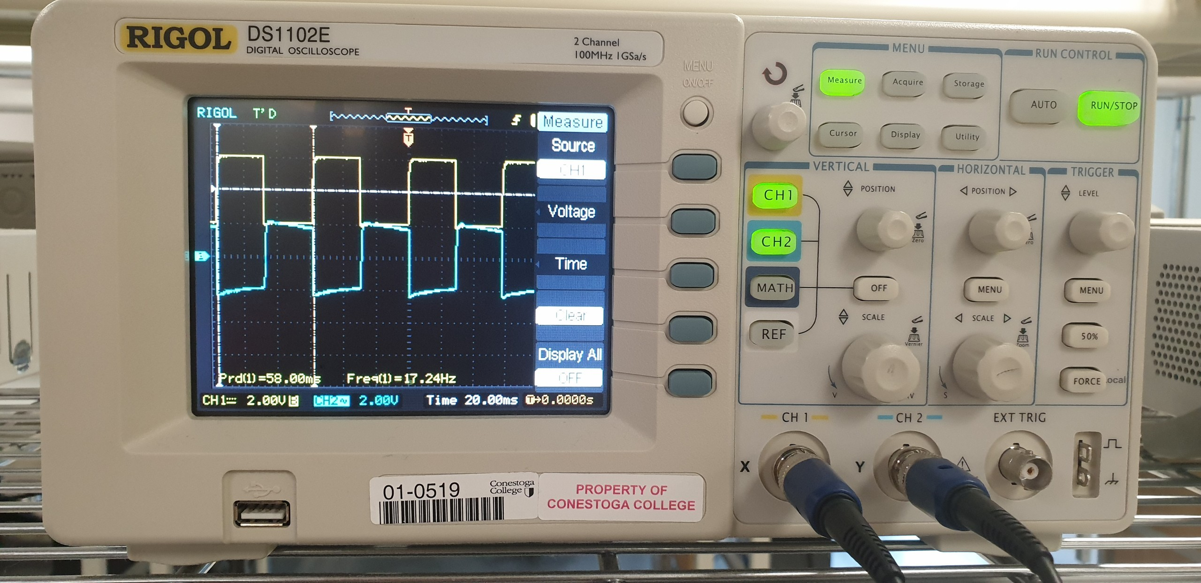

Figure 3‑4: Breadboard's output for 16 Hz

### Result

|  |  |  |
| --- | --- | --- |
| Theory expected frequency (Hz) | Multisim’s frequency (Hz) | Breadboard’s frequency (Hz) |
| 15.38Hz | 18.2Hz | 17.24Hz |

Table 3‑1: Result for 16 Hz

## 33 Hz

### Calculation for equipment

Because $R_{2}= R_{3}$ and $C_{1}= C_{2}$ so,

$$t_{1}= t_{2}= ln\left(2\right) ×R_{2}×C_{2}$$

To design an Astable Multivibrator with 33 Hz, the periodic time will be:

So t1 and t2 will be.

From the result, choosing R2 = and C2 = 1 will be best:

$$t_{1}= ln\left(2\right) ×R_{2}×C_{2}=15.246\left(ms\right)$$

$$f= \frac{1}{T}= \frac{1}{2 × t_{1}}=32.79 (Hz)$$

### Multisim Design

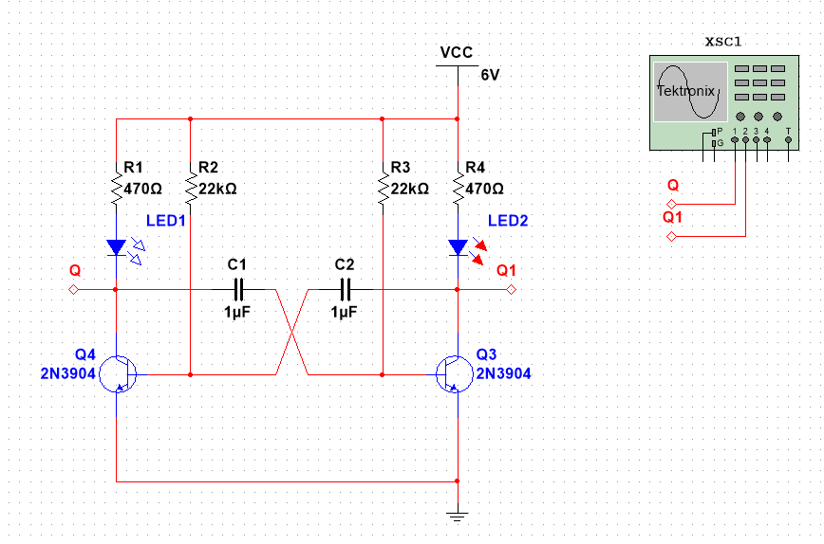

Figure 3‑5: Circuit design with R = $22kΩ$ and C = 1 $μF$

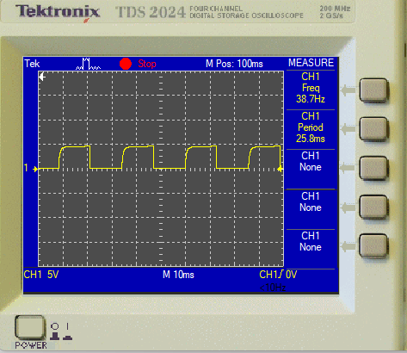

Figure 3‑6: Circuit's output for 33 Hz

### Breadboard Design



Figure 3‑7: Breadboard's design for 33 Hz

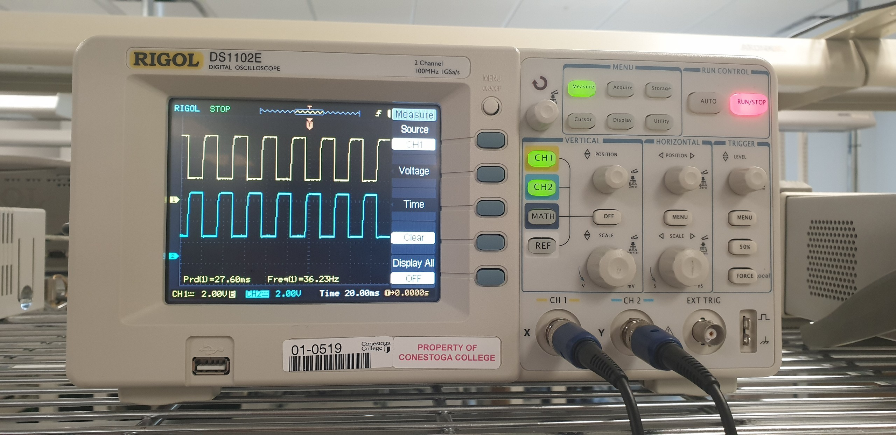

Figure 3‑8: Breadboard's output for 33 Hz

### Result

|  |  |  |
| --- | --- | --- |
| Theory expected frequency (Hz) | Multisim expected frequency (Hz) | Breadboard expected frequency (Hz) |
| 32.79 Hz | 38.7 Hz | 36.23 Hz |

Table 3‑2: Result for 33 Hz

## 80 Hz

### Calculation for equipment

Because $R_{2}= R_{3}$ and $C_{1}= C_{2}$ so,

$$t_{1}= t_{2}= ln\left(2\right) ×R_{2}×C_{2}$$

To design an Astable Multivibrator with 80 Hz, the periodic time will be:

So t1 and t2 will be.

From the result, choosing R2 = and C2 = will be best:

$$t_{1}= ln\left(2\right) ×R_{2}×C_{2}=6.93 \left(ms\right)$$

$$f= \frac{1}{T}= \frac{1}{2 × t_{1}}=72.15 (Hz)$$

### Multisim Design

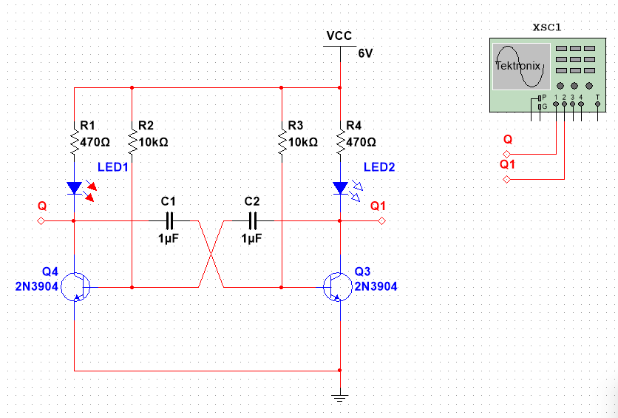

Figure 3‑9: Circuit design with R2 = and C2 =

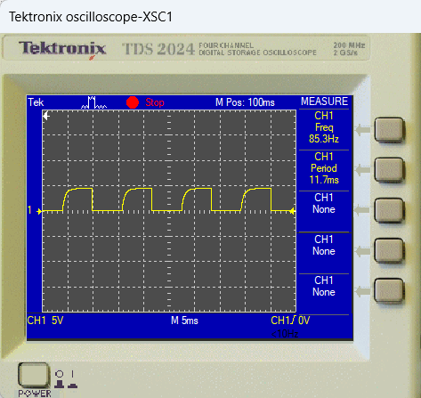

Figure 3‑10: Circuit's output for 80 Hz

### Breadboard Design



Figure 3‑11: Breadboard's design for 80 Hz

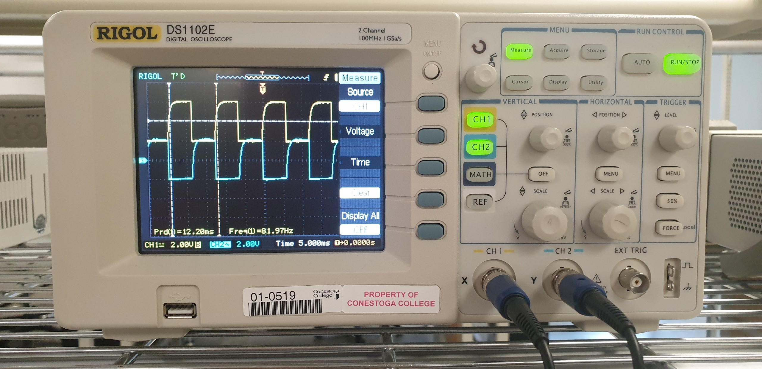

Figure 3‑12: Breadboard's output for 80 Hz

### Result

|  |  |  |
| --- | --- | --- |
| Theory expected frequency (Hz) | Multisim expected frequency (Hz) | Breadboard expected frequency (Hz) |
| 72.15 Hz | 85.3 Hz | 81.97 Hz |

Table 3‑3: Result for 80 Hz

## 5 Hz

### Calculation for equipment

Because $R_{2}= R_{3}$ and $C_{1}= C_{2}$ so,

$$t_{1}= t_{2}= ln\left(2\right) ×R_{2}×C_{2}$$

To design an Astable Multivibrator with 5 Hz, the periodic time will be:

So t1 and t2 will be.

From the result, choosing R2 = and C2 = will be best:

$$t_{1}= ln\left(2\right) ×R_{2}×C_{2}=152.46 \left(ms\right)$$

$$f= \frac{1}{T}= \frac{1}{2 × t_{1}}=6.56 (Hz)$$

### Multisim Design

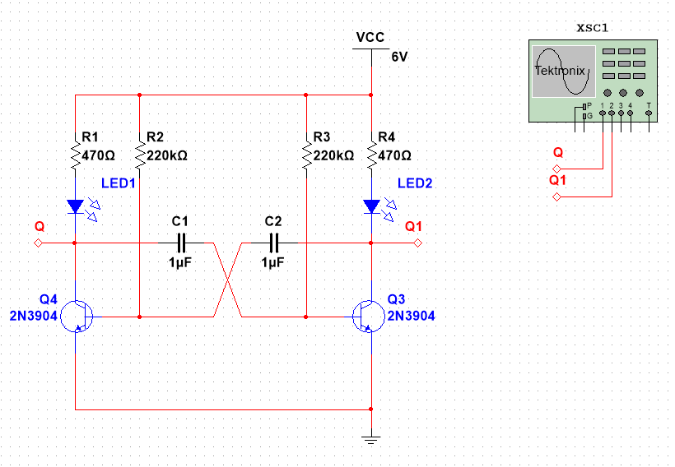

Figure 3‑13: Circuit design with R2 = and C2 =

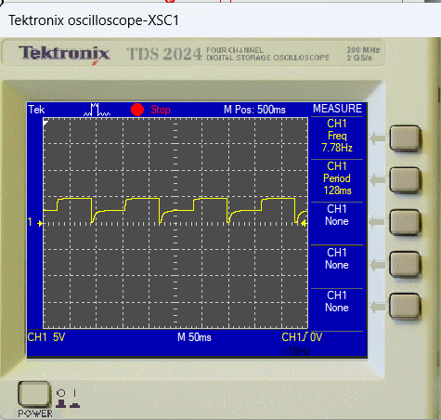

Figure 3‑14: Circuit's output for 5 Hz

### Breadboard Design



Figure 3‑15: Breadboard's design for 5 Hz

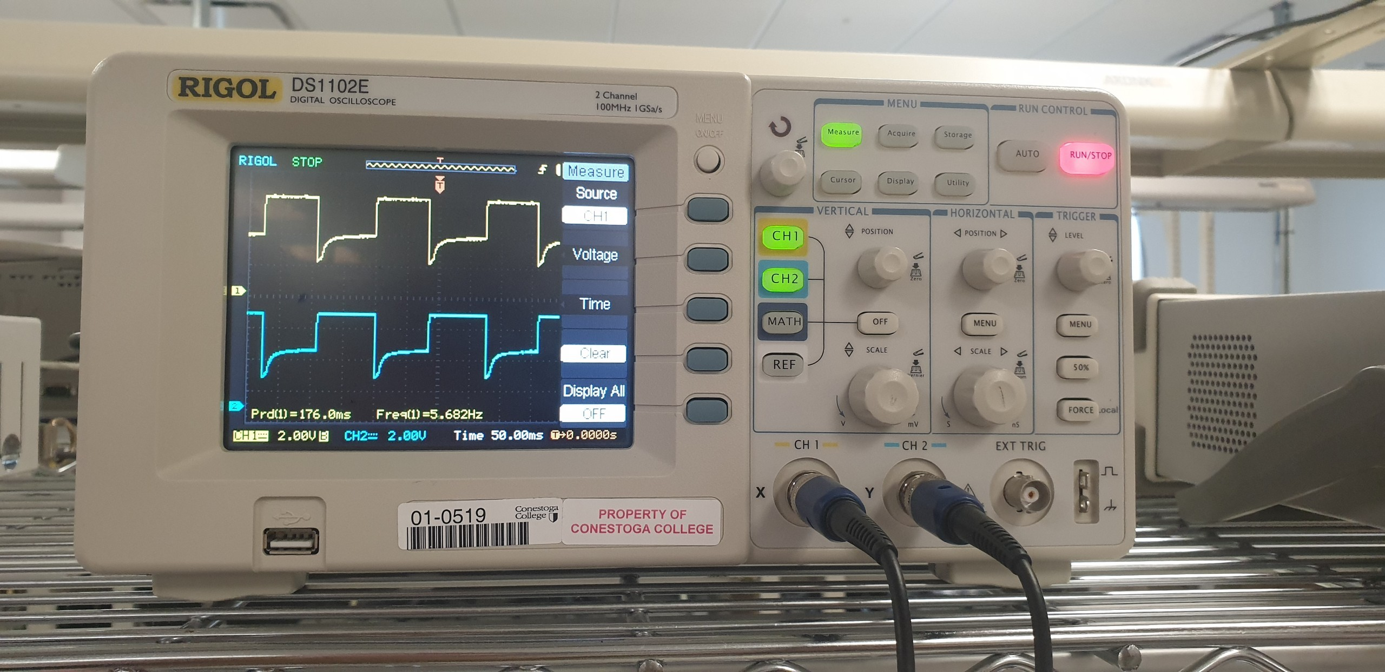

Figure 3‑16: Breadboard's output for 5 Hz

### Result

|  |  |  |
| --- | --- | --- |
| Theory expected frequency (Hz) | Multisim expected frequency (Hz) | Breadboard expected frequency (Hz) |
| 6.56 Hz | 7.78 Hz | 5.682 Hz |

Table 3‑4: Result for 5 Hz

## 20 Hz (67% ON and 33% OFF)

### Calculation for equipment

To design an Astable Multivibrator with 25 Hz, the periodic time will be:

Let t1 is the duration of ON time and t2 is the duration of OFF time,

$$T= t_{1}+ t_{2}=3 × t_{2}$$

$$t_{2}=\frac{T}{3}=16.67 (ms)$$

$$t_{1}=\frac{2 × T}{3}= 33.33 (ms)$$

From the result, choosing R2 = 47k, C2 = and R3 = 22k, C1 = will give the closest result:

$$t_{1}= ln\left(2\right) ×R_{2}×C_{2}=32.571\left(ms\right)$$

$$t_{2}= ln\left(2\right) ×R_{3}×C_{1}=15.247\left(ms\right)$$

$$f= \frac{1}{T}= \frac{1}{t_{1} {+ t}_{2}}=20.91 (Hz)$$

### Multisim Design

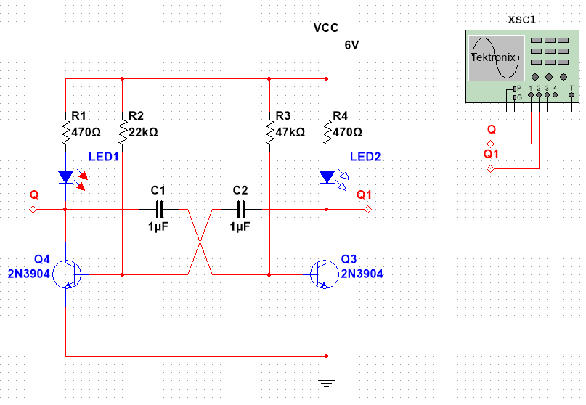

Figure 3‑17: Circuit design with R2 = 47k, C2 = and R3 = 22k, C1 =

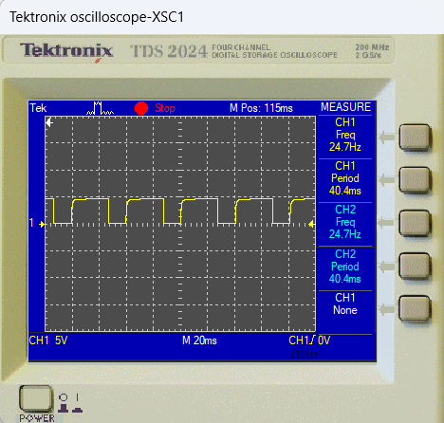

Figure 3‑18: Circuit's output of Chanel 1 for 20Hz (67% ON, 33% OFF time)

Time: 20ms/div

From figure 3-14, T taken up 2 squares with t1 occupied 3/5 square and t2 occupied 7/5 square so,

$$t_{1}=\frac{3 × T}{10}=12 \left(ms\right) (ON time)$$

$$t_{1}=\frac{7 × T}{10}= 28 \left(ms\right) (OFF time)$$

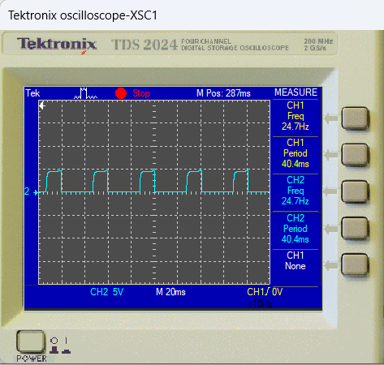

Figure 3‑19: Circuit's output of Chanel 2 for 20Hz (33% ON, 67% OFF)

Time: 20ms/div

From figure 3-14, T taken up 2 squares with t1 occupied 3/5 square and t2 occupied 7/5 square so,

$$t_{1}=\frac{7 × T}{10}=12 \left(ms\right) (ON time)$$

$$t_{1}=\frac{3 × T}{10}= 28 \left(ms\right) (OFF time)$$

### Breadboard Design



Figure 3‑20: Breadboard's design for 20 Hz

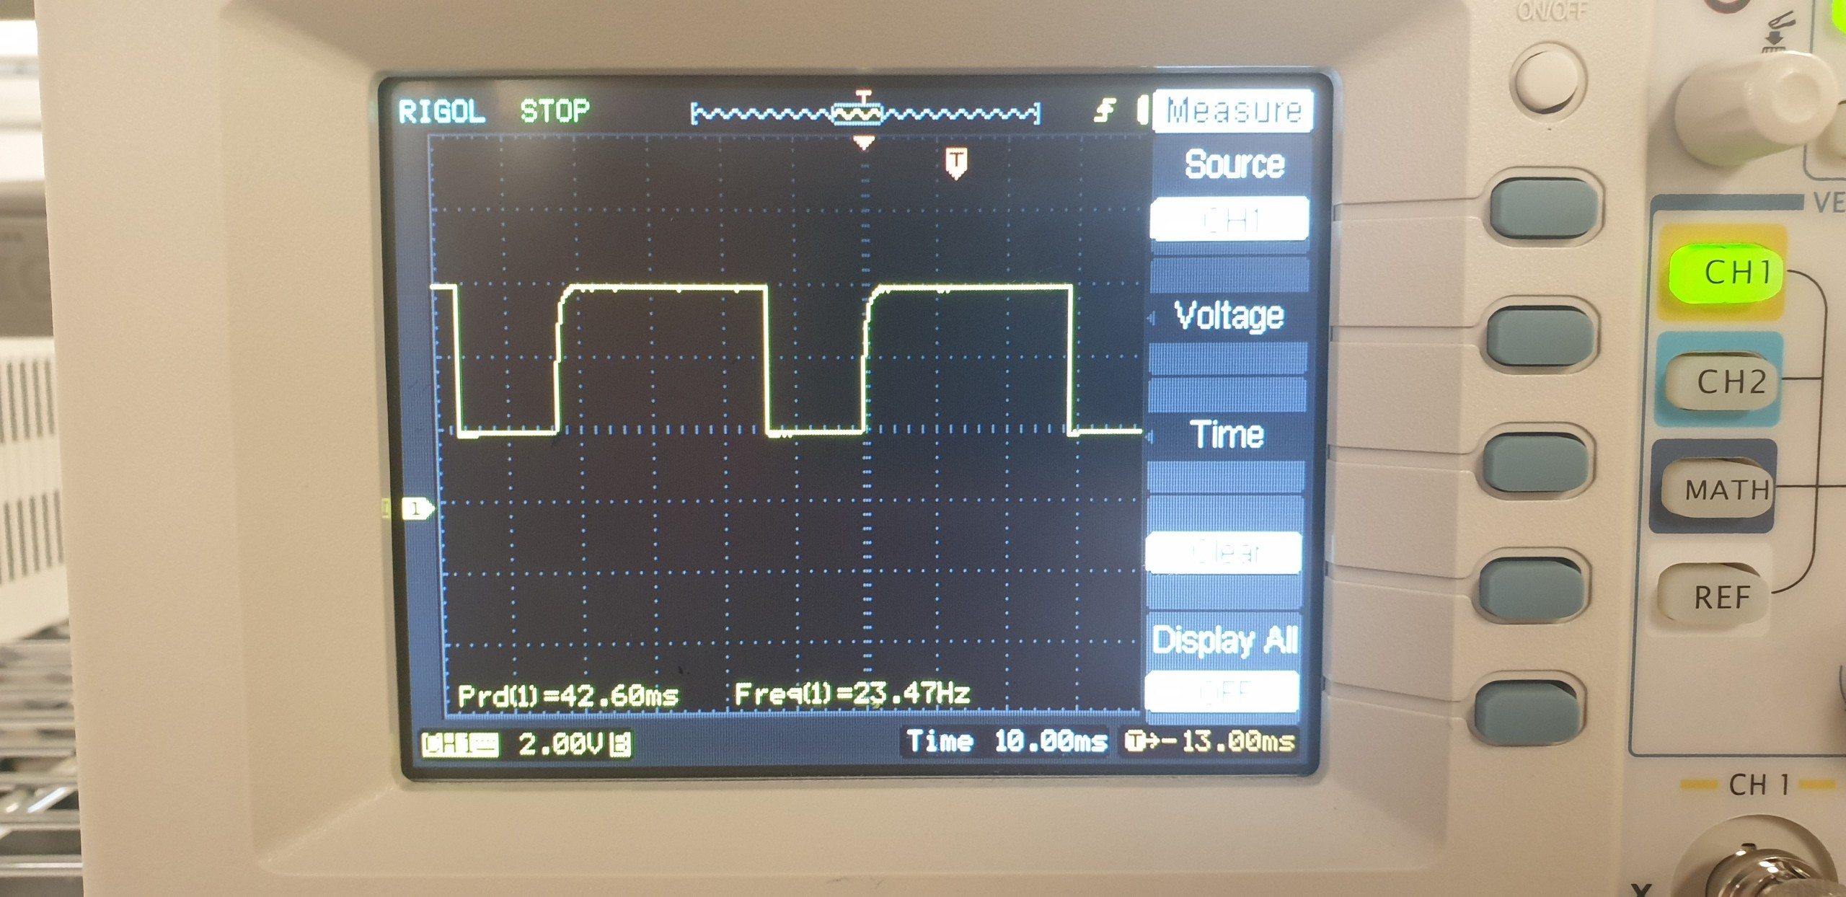

Figure 3‑21: Breadboard's output for 20Hz (Channel 1)

Time: 10ms/div

From figure 3-14, T taken up 4.2 squares with t1 occupied 3 square and t2 occupied 1.2 square so,

$$t_{1}=\frac{3 × T}{4.2}=30.43 \left(ms\right) (ON time)$$

$$t_{1}=\frac{1.2 × T}{4.2}= 12.17 \left(ms\right) (OFF time)$$

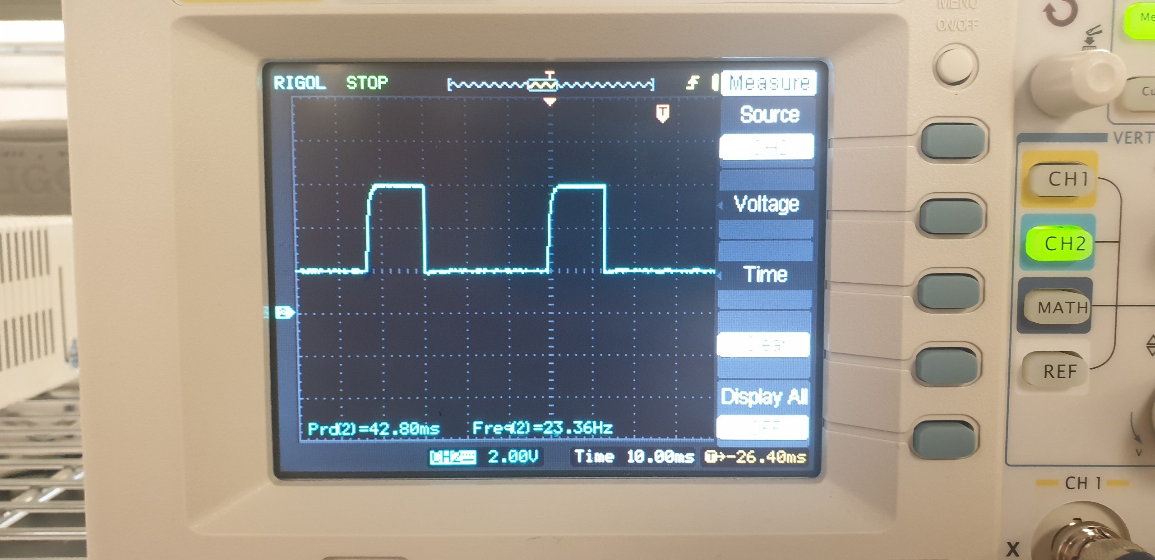

Figure 3‑22: Breadboard's output for 20Hz (Channel 2)

Time: 10ms/div

From figure 3-14, T taken up 4.2 squares with t1 occupied 1.2 square and t2 occupied 3 square so,

$$t_{1}=\frac{1.2 × T}{4.2}=12.17 \left(ms\right) (ON time)$$

$$t_{1}=\frac{3 × T}{4.2}= 30.43 \left(ms\right) (OFF time)$$

### Result

|  |  |  |
| --- | --- | --- |
| Theory expected frequency (Hz) | Multisim expected frequency (Hz) (Channel 1) | Breadboard expected frequency (Hz) (Channel 1) |
| f = 20.91 Hz  t1 = 32.571 ms  t2 = 15.247 ms | f = 24.7 Hz  t1 = 28 ms  t2 = 12 ms | f = 23.47 Hz  t1 = 30.43 ms  t2 = 12.17 ms |

Table 3‑5: Result for 20 Hz

# CONCLUSION

From the result of all 5 cases:

* All 5 cases have Multisim’s result and Breadboard’s result nearly the same.
* Although there is a slight big difference when comparing the error of Theory’s with Multisim’s and Multisim’s with Breadboard’s, the error is still acceptable.

**REFERENCES**